16.Your application amazon elastic compute cloud (EC2) instances…………….storage service (s3) bucket.

Which one of the following methods should you use to securely ………………the instances in a cost-effective way?

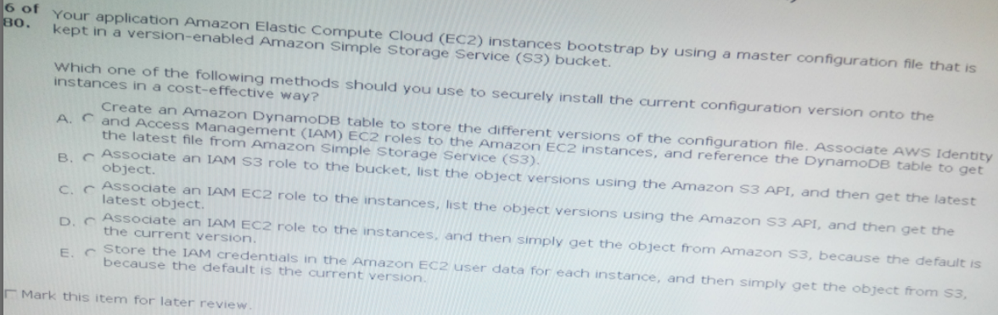

Ans:D

17.Your company operates a website for promoters to………….enough, leading to user disappointment.

What options should you choose to improve scaling yet minimize costs?

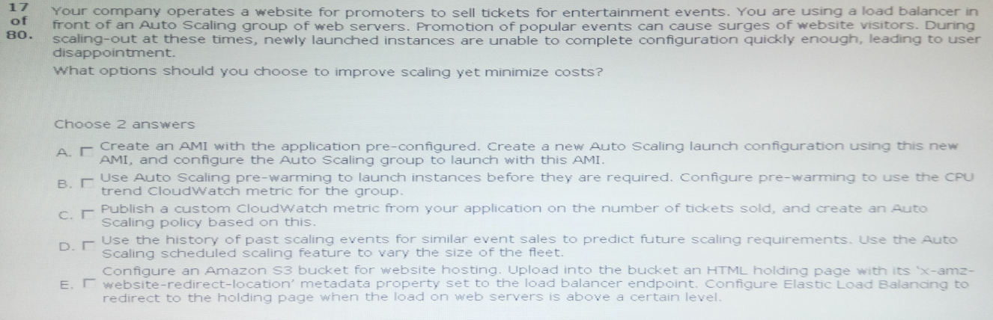

ANs: A,D

18.Your application requires a fault-tolerant, low-latency and repeatable method to load configuration files via auto scaling when ……launch.

Which approach should you use to satisfy these requirements?

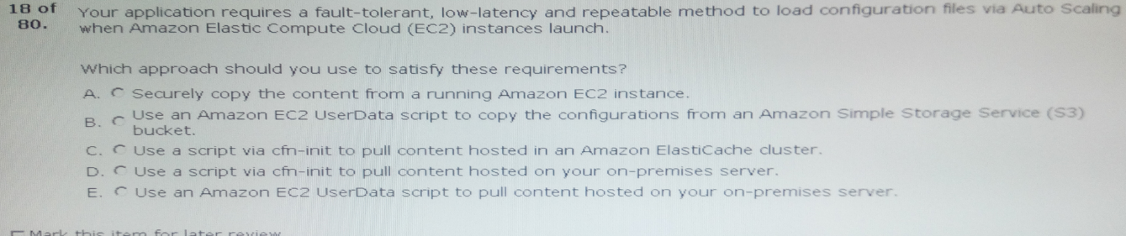

Ans: B

19.Currently, your deployment process consists of setting your load balancer to point to a maintenance……….more agile deployment process.

Which techniques could you use to provide a cost–effective rolling deployment process?

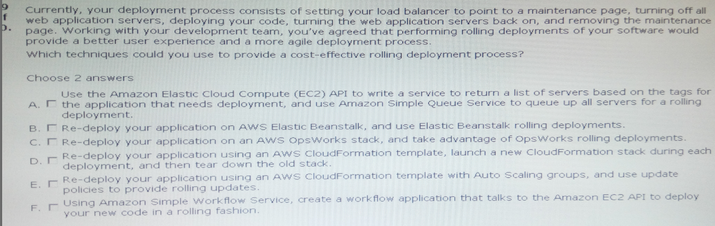

Ans: B,C

20.You manage a web advertising platform on a single aws account. This…………….to the ad-click data so that they can run analytics.

Which two choices are required to facilitate secure access to this data?

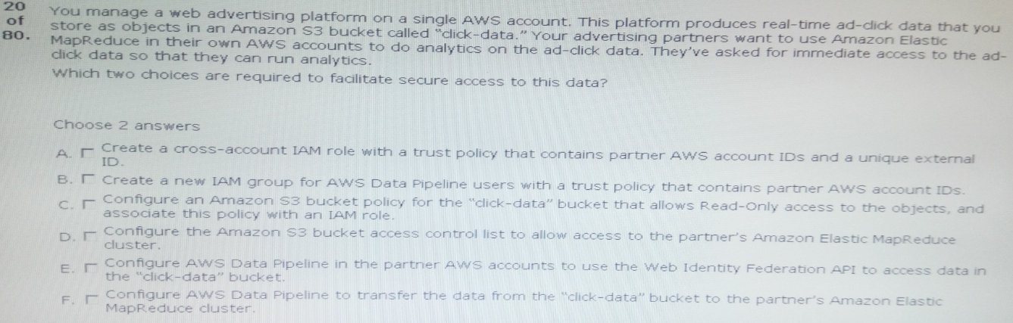

Ans: A,C

21.You run a SIP-based telephony application that uses amazon ec2 for its web tier and uses mysql on amazon RDS as its database. The application stores only the authentication profile data for its existing

………..is read-intensive.

You monitoring system shows that your web instances and the database have high CPU utilization.

Which of the following steps should you take in order to ensure the continual availability of your application?

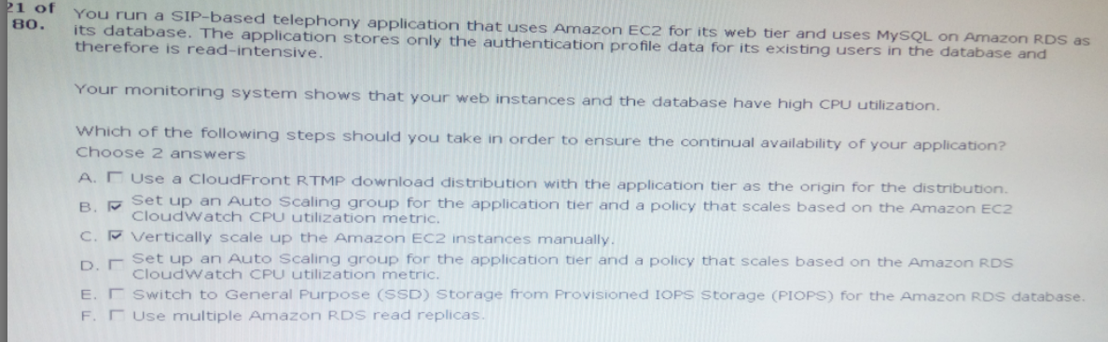

Ans:B,F

22.Your team is responsible for an aws ………………………back to the previous version almost immediately in an emergency?

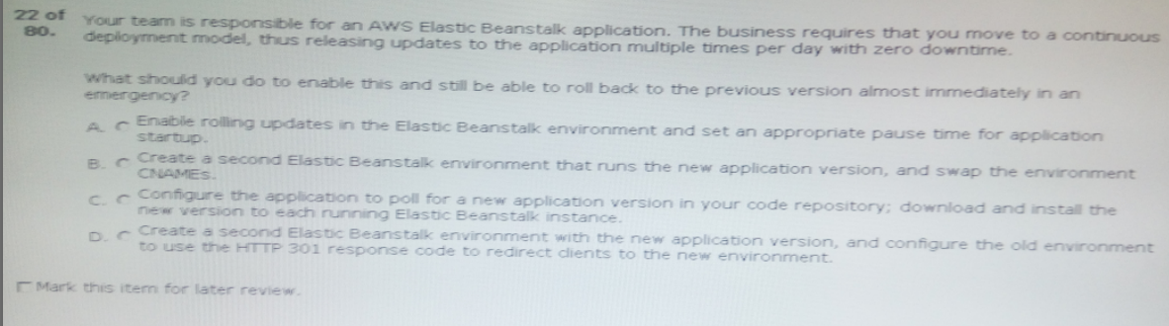

Ans:B

23.you have just come from your chief information security officer’s (CISO) office with the instructions……………….

::::::::::::::::::::::::::::::::::::::::::::::::::::::::::::::::::::::::::::::::::::::::::::::::::::::

Which two additional pieces of logic should you include to meet the CISO’s requirements?

ANs: A,C

24.You are responsible for a large-scale video transcoding system that operates with an auto scaling  ………………………………………………………..very large.

How can you resolve the alarm without the risk of increasing the time to transcode videos?

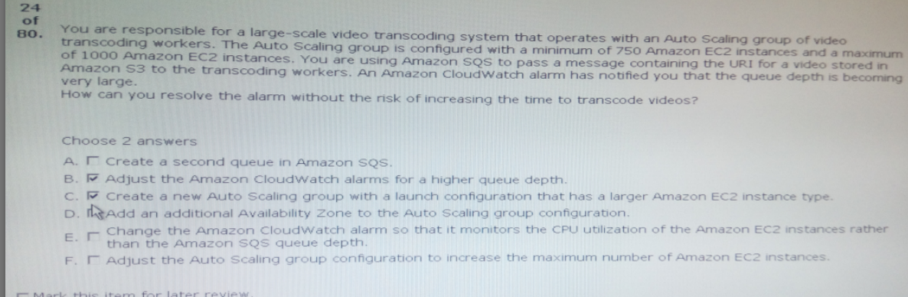

Ans:C,F

25.You have been tasked with deploying a solution for your company that will store images, which the marketing department …………………………………….upload if required.

How should you design this solution in the most highly available and cost-effective way?

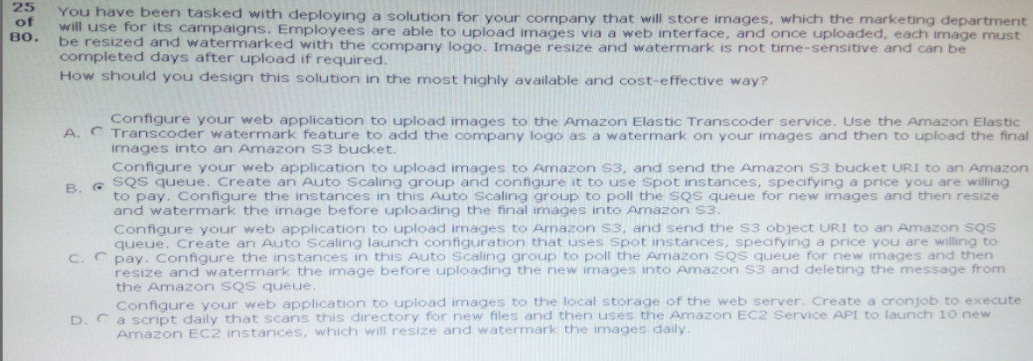

Ans: C

26.You run a small online consignment marketplace. Interested sellers complete an online application in order to allow the to …………………….are being charged twice.

How can you resolve these problems?

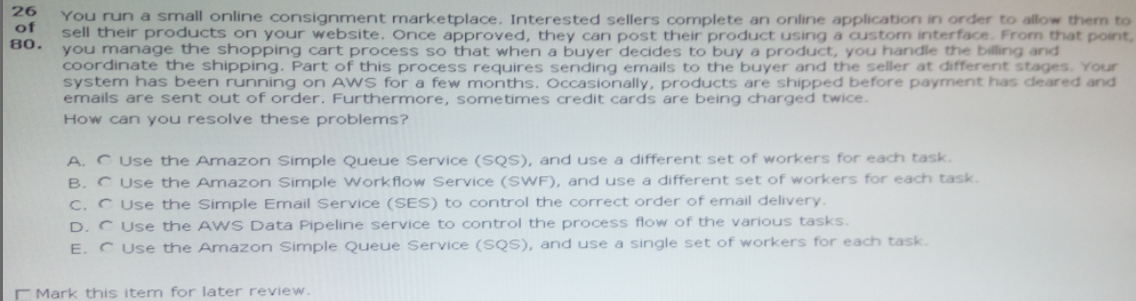

Ans: B

27.Your application has an auto scaling group of m3.large instances running ………………….causes a memory leak.

What cost-effective steps can you take to continue message processing while the library developer fixes the bug?

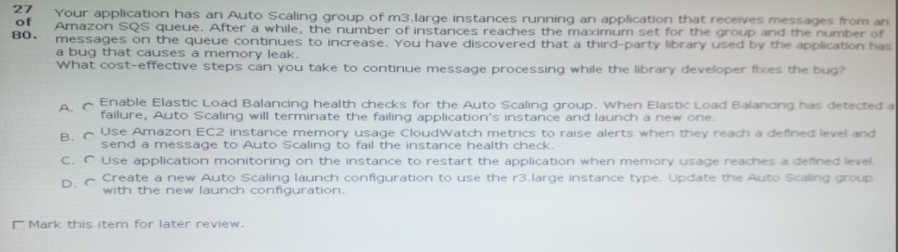

Ans: D

28.You are in charge of a large-scale highly available multi-tier web application infrastructure. This architecture consists of ………….style deployments.

Which technique should you use to deliver this new requirement?

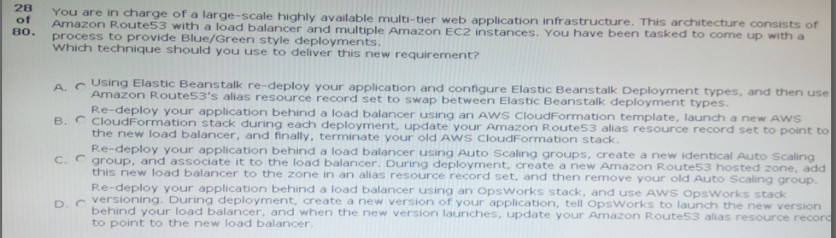

Ans:B

29.Your application uses amazon SQS and auto scaling to process background jobs. The auto scaling policy is based on the number of ………………….is at normal levels.

What should you do to identify why the queue size is unusually high, and to reduce it?

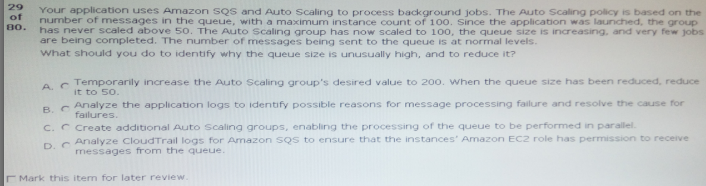

Ans:B

30.Due to compliance regulations, management has asked you to provide a system that all……. ……

………to the systems to view live logs.

What method should you use to become compliant while also providing a faster way for support staff to have access to logs?

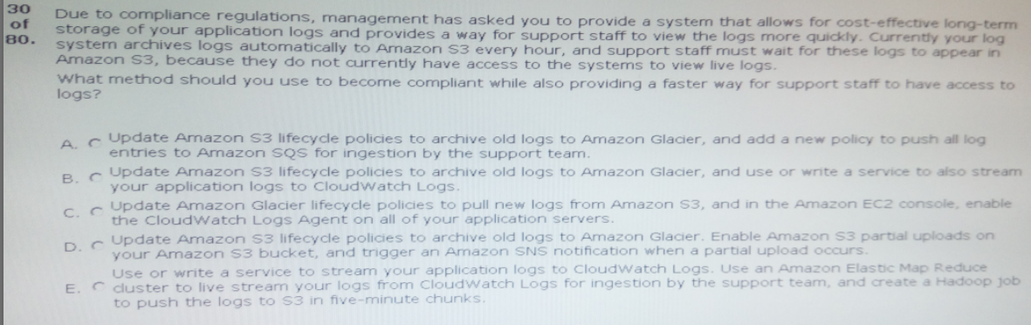

Ans:E

31.You want to securely distribute credentials for your amazon RDS instance to your fleet of web server …………………………………….configuration management system.

How do you securely deploy the …………………..number in the hundreds, while retaining the ability to roll back if needed?

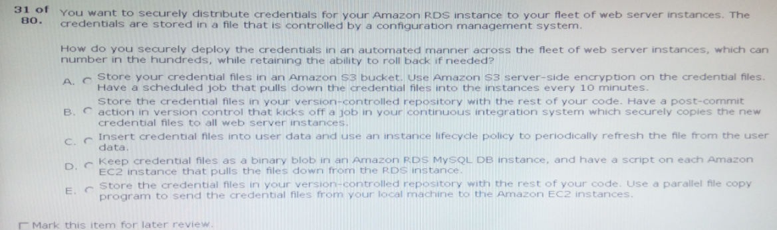

Ans:A

32.You are using a configuration management system to manage …………for connection to an amazon RDS DB instance.

How should you securely store these credentials?

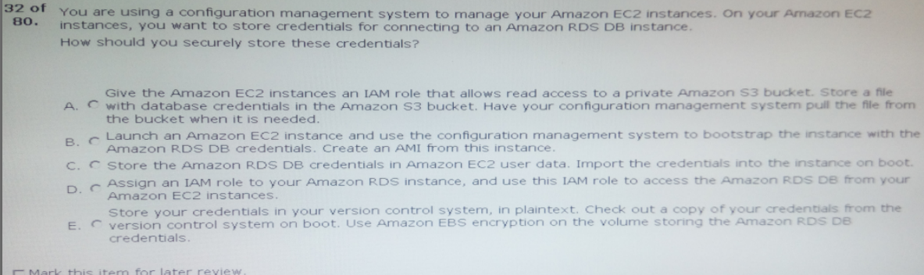

Ans:A

33.Your company has developed a web application and is hosting it in an amazon s3 bucket configured …………………………amazon DynamoDB table.

How can you ensure that API keys for access to your data in dynamodb are kept secure?

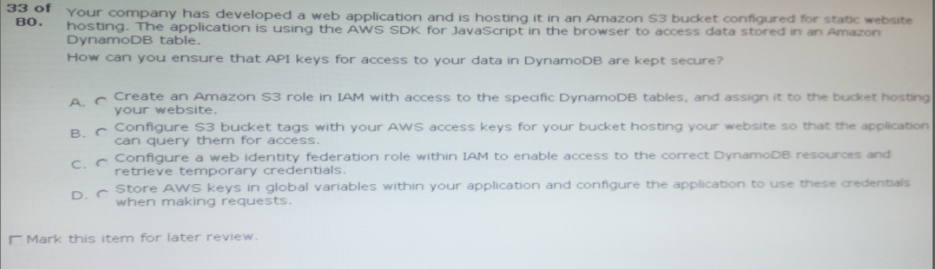

Ans:A

34.you need to implement a/b deployments for several multi-tier web…………database (RDS) instances.

Which combination of services would give you deployed versions of your application?

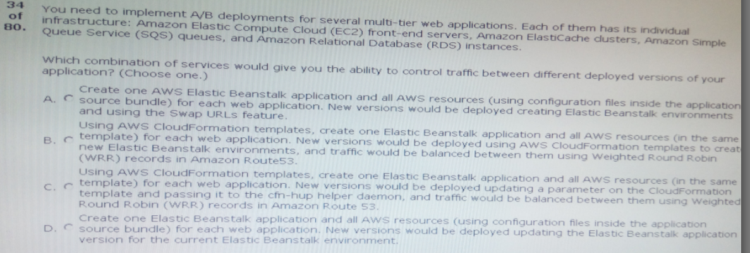

Ans:B

35.you work for an insurance company and are responsible for the day-to-day ………..;;;;;;;;;;;;;;;;;;;;;;;;

::::::::::::::::::::::::::::::::::::::::::::::::::::::::::::::::::::::::::::::::::::::::::::::::::

How would you meet these requirements in a cost-effective manner?

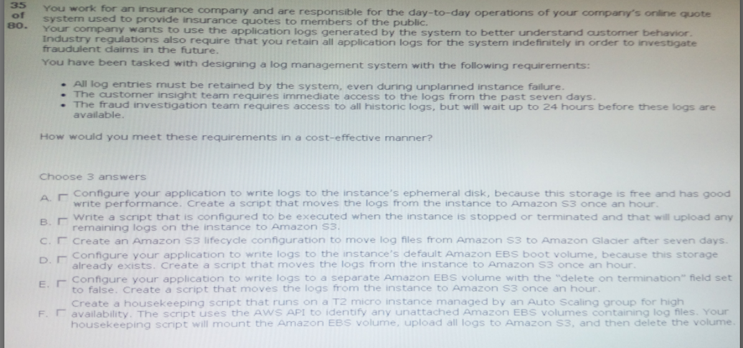

Ans:C,E,F

36.You have an application running on amazon EC2 in an auto ……………………………….

…….unknown instances.

Which of the following will ensure that new instances are not added to your application monitoring tool before bootstrapping is completed?

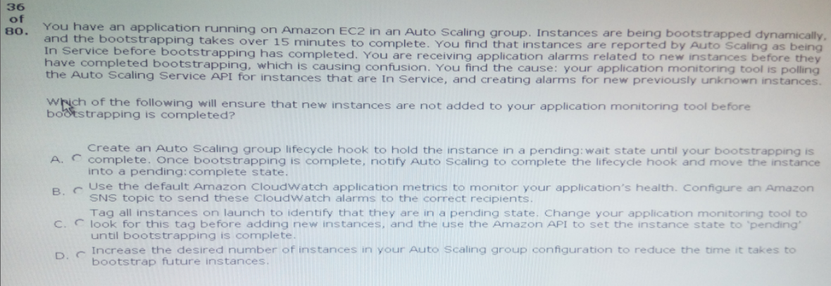

Ans:A

37.you have been give a business requirement to retain log files…………….logs. what technique should you use to meet these requirements?

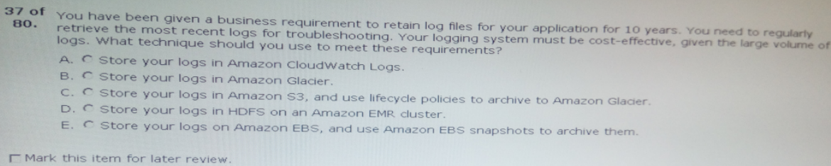

Ans:C

38.you work for a startup that has developed a new photo …………….;;;;;;;;;;;;;;;;;;;;;;;;;;;;;

;;;;;;;;;;;;;;;;;;;;;;;;;;;;;;;;;;;;;;;;;;;;m3 instances to the compute-optimized c3 instances.

How would you deploy this change while minimizing any interruption to your end users?

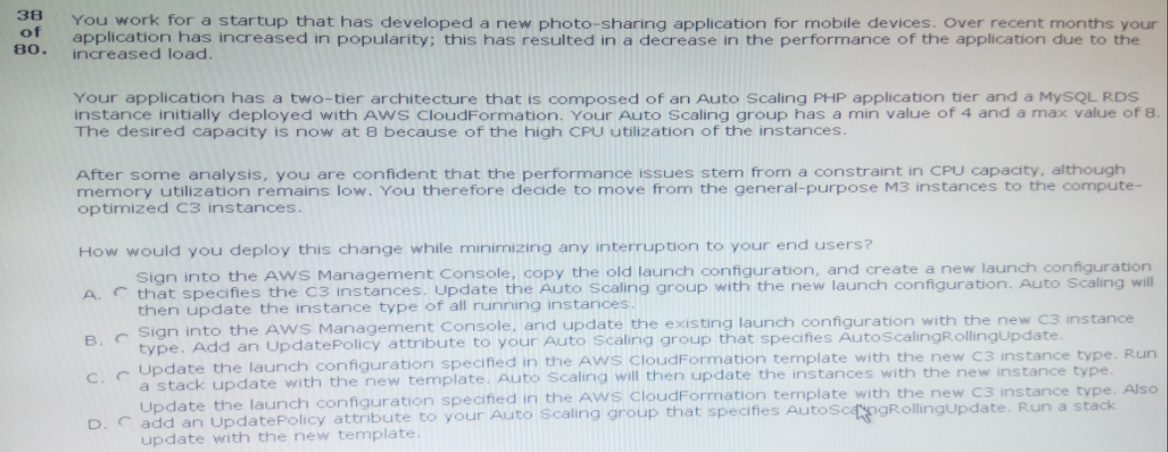

Ans:D

39.You’ve been tasked with implementing an automated data backup solution for …………………

;;;;;;;;;;;;;;;;;;;;;;;;;;;;;;;;;;;;;;;;;;;;;;;;;;;;;;;;;;;;;;;;data within an hour.

How can you implement this through a script that a scheduling daemon runs daily on the application servers?

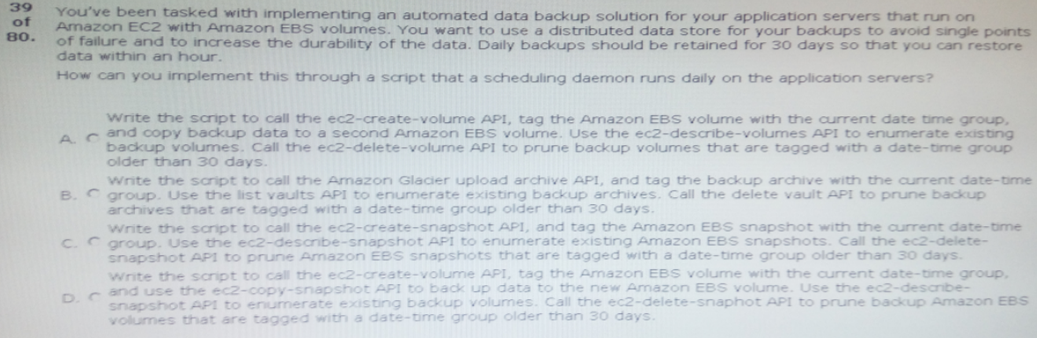

Ans:C

40.Your application uses cloudformation to orchestrate your application’s……………….. loss of test data.

How should you prevent this from occurring in the future?

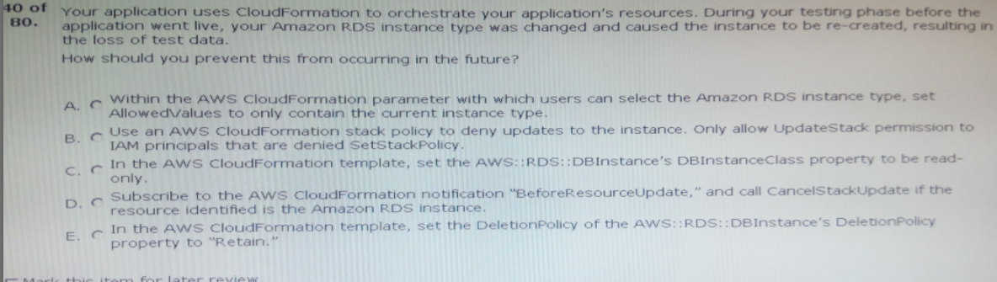

Ans:A

41.Your company develops a variety of web applications using many platforms …………….

………. Business requirements.

Which of the following methods should you use to deploy these applications rapidly?

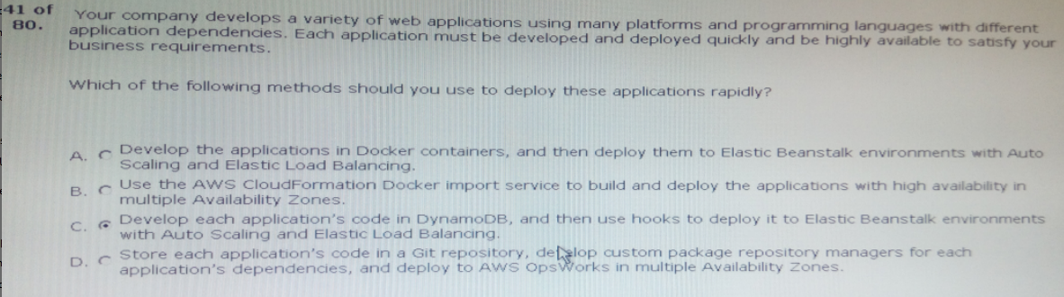

Ans:A

42.You have a large number of web servers in an auto scaling group behind a load …………………………..

……….initiated by a user or by auto scaling.

What two approaches will meet these requirements?

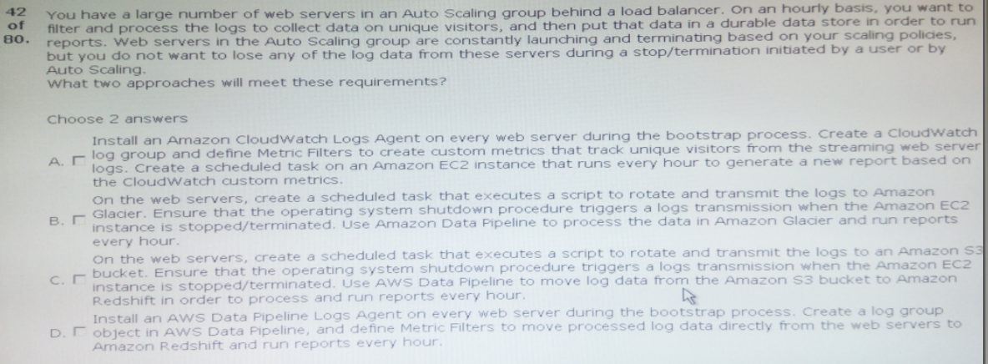

Ans:A,C

43.You have been tasked with deploying a scalable distributed system using aws ………….within the layer.

How should you configure aws opsworks to manage scaling this application dynamically?

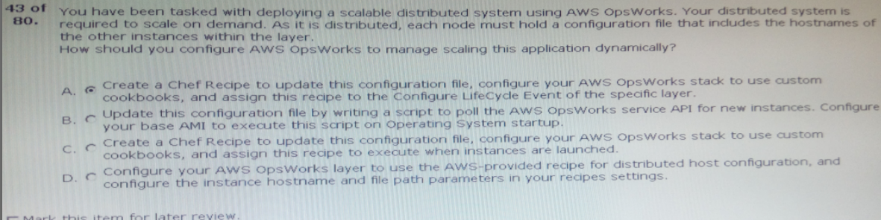

Ans:C

You have an application running on an amazon ec2 instance …………………..aws service apis.

How can…….to retrieve the api keys for use with the aws sdks

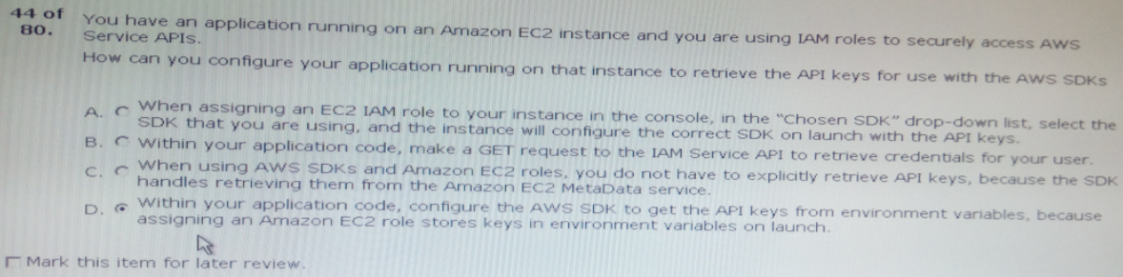

Ans:C

45.when an auto scaling group is running in amazon ………………………terminated amazon ec2 resources are still showing as active.

What would be a reliable and efficient way to ………. Within your configuration management system?

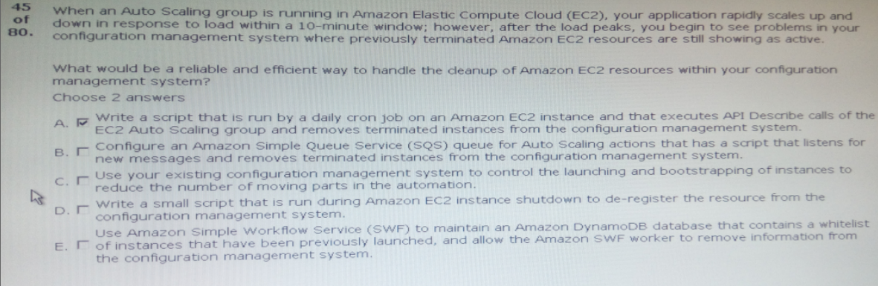

Ans:A,D

46.You have enabled elastic load balancing HTTP health ………………………….site is not responding.

What is the cause?

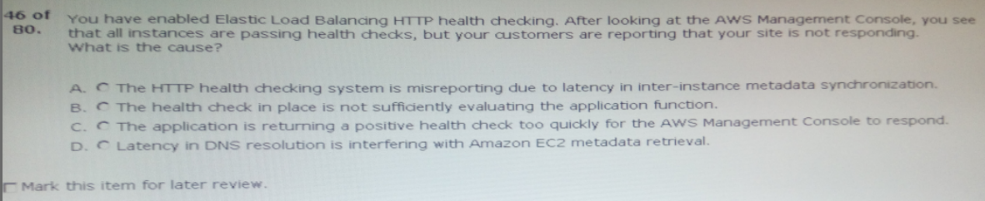

Ans:B

47.You use amazon cloudwatch as your primary monitoring system for your web ………………………..

………………………..these occur.

How can you accomplish this using AWS services?

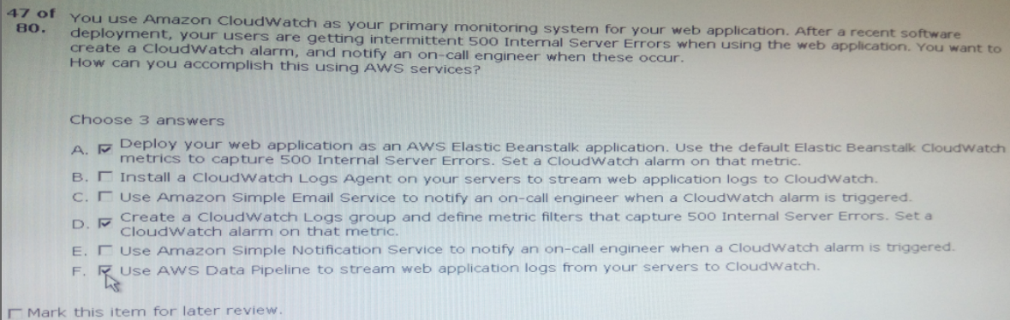

Ans:B,D,E

48.After a daily scrum with your development teams, you’ve agreed that using Blue/Green style deployments would benefit the team.

Which technique should you use to deliver this new requirement?

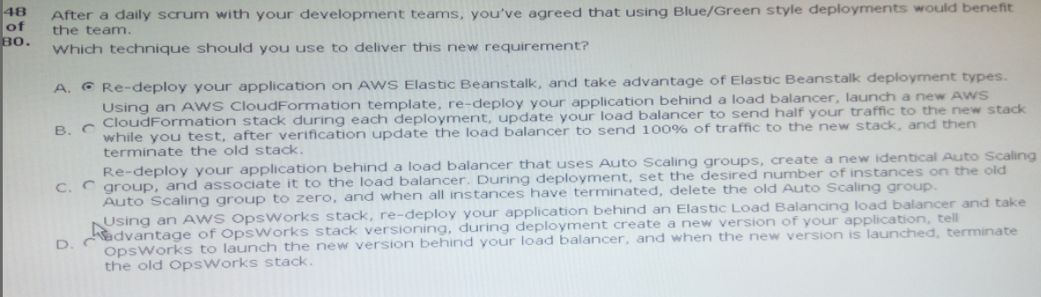

Ans:D

49.You have a complex system that involves networking, IAM policies, and multiple,three …….

……….agile new environments for your customers in a cost-effective, reliable manner?

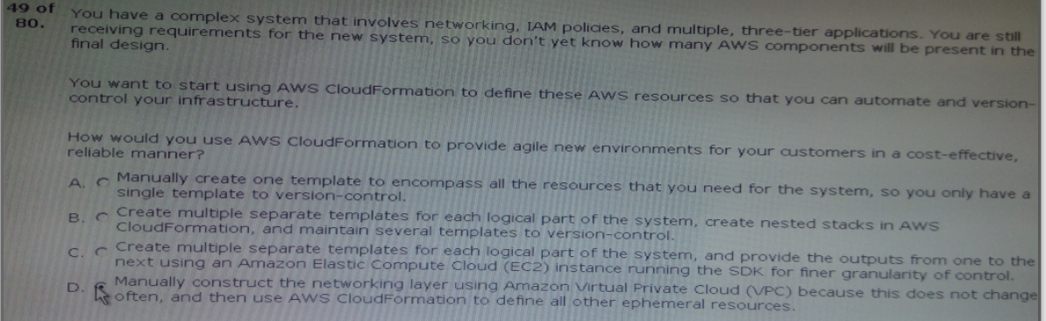

Ans:B

50.Your development team wants account-level access ……………secure environment.

Which of the following should you do?

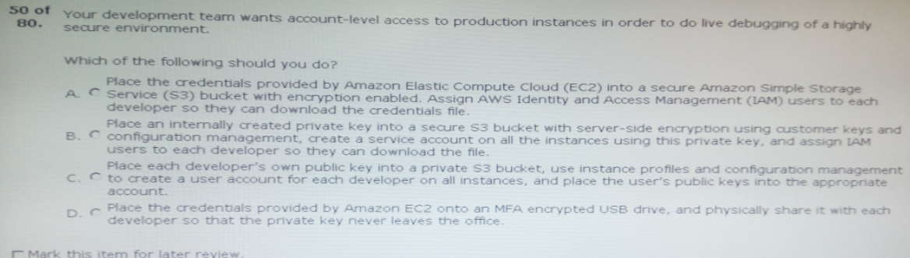

Ans:B